AWARD
2020

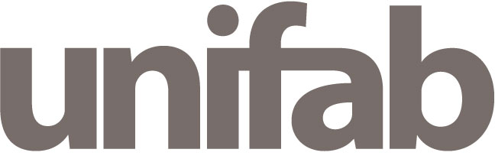

UNIFAB Award - 25^{è} FORUM EUROPEEN DE LA PROPRIETE INTELLECTUELLE
26 & 27 MARS 2020
UNIFAB Award - 25th EUROPEAN FORUM OF INTELLECTUAL PROPERTY
MARCH 26th & 27th, 2020

CANDIDATURE

APPLICATION

A retourner par mail / To return by email : rmessali@unifab.com

ENTREPRISE / COMPANY - CABINET / FIRM

Entreprise / Cabinet – Company / Firm …………………………………………………………………………………...
Représentant / Point of contact ……………………………………………………………………………………
Tél. …………………………………………………………………………………...
e-mail …………………………………………………………………………………...

Facultatif / facultative
Cabinet d’avocat / Law Firm ……………………………………………………………………………………
Représentant / Point of contact ……………………………………………………………………………………
Tél. …………………………………………………………………………………...
e-mail …………………………………………………………………………………...

JURISPRUDENCE / CASELAW

Date de la décision / Date of the caselaw ……………………………………………………………………………………
Lieu d’obtention / Place of the verdict ………………………………………………………………………………………..
Discipline / Discipline ……………………………………………………………………………………………………………………
L’ensemble de la décision est à joindre à cette fiche de candidature
The entire caselaw has to be joined to this application form

Contact : Régis Messali 00 33 1 56 26 14 07 – 00 33 6 16 89 00 81 rmessali@unifab.com

